Client Name: Veena Mittal (P2)

Programmer: Ajay P

Title: **Design and develop a Hybrid structural Attention-enabled explainable Convolutional Neural Network for rice leaf disease classification**

* **Python Version: 3.8.10**
* **OS: Windows 11**

**Block Diagram:**

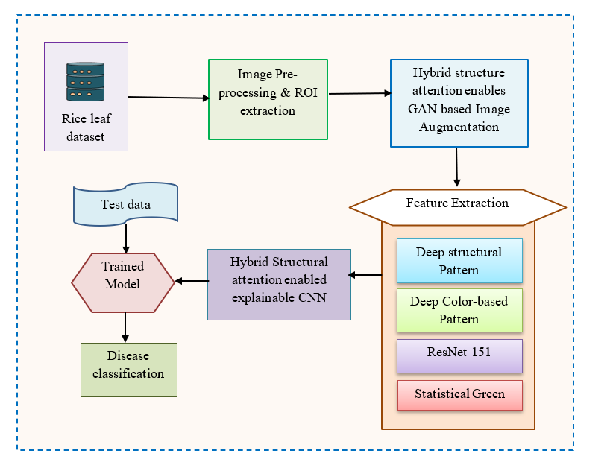

INPUT DATASET LINK:

Dataset 1: <https://www.kaggle.com/datasets/vbookshelf/rice-leaf-diseases>

Classes: Leaf smut, Brown spot, Bacterial leaf blight

Shape: N,150,150,3

Dataset2: <https://data.mendeley.com/datasets/dwtn3c6w6p/1>

Classes: Bacterial leaf blight, Brown Spot, Leaf smut

Shape: N,150,150,3

Dataset3: <https://www.kaggle.com/datasets/nirmalsankalana/rice-leaf-disease-image>

classes: Bacterial blight, Blast, Brown Spot, Tungro

Shape: N,150,150,3

Input Type: Images ===> Image Format JPG

PREPROCESSING:

1. Applied Median Filter to remove Noise

2.ROI Extraction – Same Shape N,150,150,3

3. Data Agumentation Using GAN:

Sample GAN images: <https://ibb.co/Wp7THLjh>

<https://ibb.co/Fk8NN0mc>

Feature Extraction:

1.Deep structural pattern: Resnet101(pretrained model used, the output is taken from the 1 st layer )

-- Resnet 101+ Structural Pattern

2. Deep Color Based Pattern: VGG16 (pretrained model used and the output is taken from the 2 nd layer )

- - - VGG16 Features+ cv2.equlizeHist+ Canny Edge

3. Resnet151: Used Resnet 152 and took features from the second layer

4. Statistical Green: Extracted only the green channel from the RGB image and slided over 3x3 and applied mean, median and standard deviation and took average of all the three

Contribution:

1. Hybrid structural attention – used CBAM + Multi Head Attention with skip connection

--- CBAM code link <https://www.kaggle.com/code/iommarz8/cnn-with-cbam-attention>